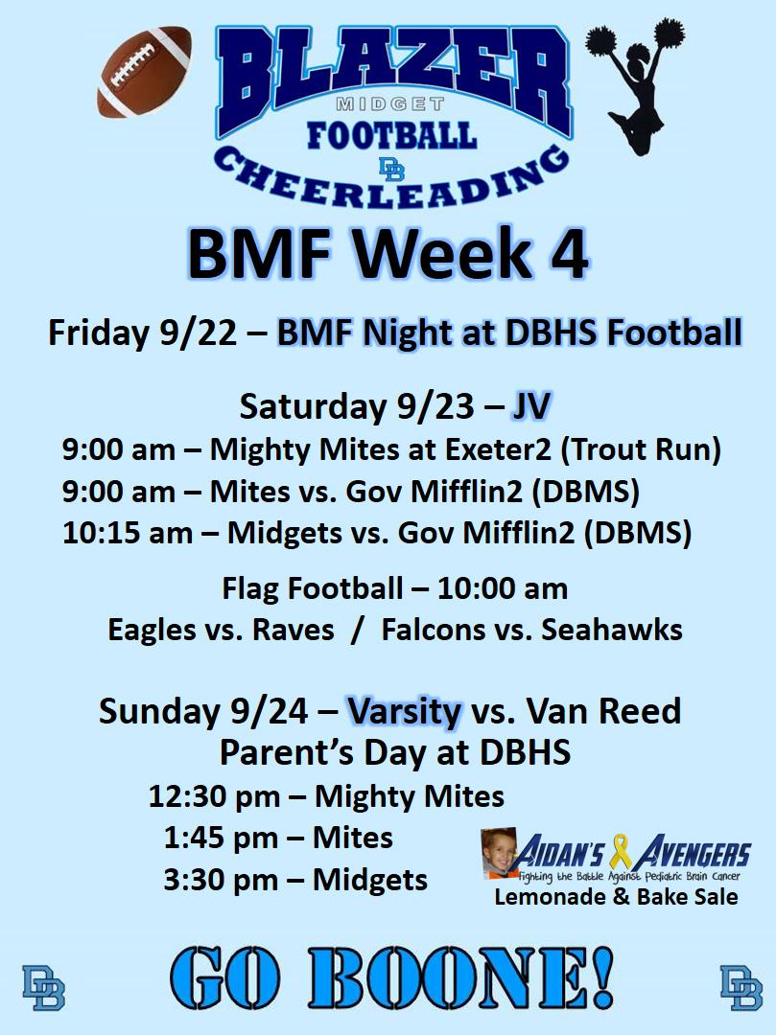
BOARD MEETING Agenda
June 24, 2025
Attendees:
Courtney nonnemaker, Amber Corbet, Chris Weller, Chad Geist, Andrew Filopanti, Celeste Fronauer, Beverly Albright, Madison Albright, Eric Martin, Mike Beto, Jeff Romig, Andrew Verguldi, Nate Romig, Lauren Cortellessa, Madison Albright, Katrina Lucas, Erin Krim, Grace Albitz.

Opening Business
- Call to Order: 8:08PM
- Approval of minutes: Beto, Martin

Reports
- President – Everything is Booked for the season.
- VP Cheer – Comps are being finalized.
- VP Football – Meeting is all set for football
- Secretary – Nothing
- Treasurer – Insurance is done (6K)
  - balance in account(s) =
- Checking: 41115.03
- MM: 20,585.98
- Savings $1
- Football League Rep (Chad Geist/ Mike Beto) – Lebanon and blue mountain dropped out. All other 9 teams straight with no bi week. Black out dates were requested and we sent them out.
- Cheerleading Operations (Erin Krim)- Nothing

- Communications (John Schiel) –Nothing new, just sending out emails as requested.

- Registration (Andrew Filopanti)–
  - Last fitting was today. Any other fittings will have to be done at equipment handouts.

- Football Equip. Mgr (Chad Geist) – helmets are all in, have been tagged and logged in.

- Cheerleading Equip. Mgr. (Celeste F)- Nothing

- Sponsorship (Alyssa Geist) – Nothing new. Waiting for some of the other sponsorships. Lords and Ladies Douglassville sent a check for $1,000. Will resend email back to Verguldi work.
- Fundraising (Ashley Beto) – . July 10th to August 10th. Spirit Wear store open. Couple designs by the end of the week. 3 Spirit baskets for fundraising. Voted as Yes. Need to have everything for August 9th for equipment handout
- Flag football commissioner (Nate Romig) – Stay in house this year. Modify the rules to stay close to the berks rules. Focus on fundamentals. Build the schedule backwards with cheer. Try for 9 games this season. Possible 4 teams of 9 kids. Nate will be point person for all flag coaches. 11 coaches have registered.

- Flag Cheer Commissioner – Nothing
- Concession Coordinator (Betsy R) – Nothing

- Graduation Day Ceremony (Board) – Nothing

- Football Coaches –
  - Midgets (Nik Stoulfutz)
  - No Report
  - Mites (Mike Beto)
  - Starting summer workouts July 7th for the month. Monday (6-8) and Saturday (9-11). French Creek has offered field time for us but not needed as of now.
  - Mighty Mites (Andrew Verguldi)
  - No Report
- Cheer Coaches

  - Flag (Grace A)
  - N/A
  - MM JV (Jess Friends)
  - N/A
  - MM V (Amanda Kehres)
  - N/A
  - Mites JV (Katrina lucas)
  - N/A
  - Mites V (Madison Albright)
  - N/A
  - Midgets V (Celeste F)
  - N/A

Items for Discussion: NA

Follow ups:
NA
New Business:
NA
Meeting adjourned: 8:30PM
Next meeting: July 20th ,2025

